Table of Contents

I. Introduction 2

II. Aim 4

III. Objectives 4

1.Develop a Centralized Customer Data Management System 4

2.Implement Sales and Lead Tracking Features 4

3.Automate Task and Workflow Management 5

4.Ensure Secure Authentication and User Role Management 5

5. Generate Reports and Data Analytics 5

6. Deploy and test the CRM System 5

IV. Legal, social, ethical, and professional 6

1. Legal 6

2. Social 6

3. Ethical 6

4. Professional 6

V. Plan 7

1. WBS 7

2. Gantt chart 8

Bibliography 8

Customer Relationship Management system proposal

# Introduction

In today's competitive business landscape, maintaining strong relationships with customers is crucial for success. A Customer Relationship Management (CRM) system is a powerful tool that helps businesses manage interactions with current and potential customers. It centralizes customer data, automates processes, and enhances communication, leading to improved customer satisfaction and business efficiency.

This project aims to develop a web-based CRM system tailored to streamline customer interactions, track sales activities, and provide data-driven insights. The system will include key features such as contact management, sales tracking, task automation, and reporting tools. By implementing this CRM, businesses can optimize their workflows, improve team collaboration, and enhance customer engagement, ultimately driving growth and profitability.

Key problems covered by this project include:

* **Disorganized Customer Data** – Many businesses struggle with scattered customer information across emails, spreadsheets, and notes, making it difficult to track interactions and preferences.
* **Inefficient Communication** – Without a centralized system, teams may have trouble coordinating follow-ups, leading to missed opportunities and inconsistent customer service.
* **Poor Sales and Lead Management** – Tracking leads and sales manually can result in lost prospects and inefficient sales processes.
* **Lack of Task Automation** – Repetitive tasks such as follow-ups, email responses, and data entry consume valuable time that could be used for strategic activities.
* **Limited Reporting and Analytics** – Without proper insights, businesses find it difficult to analyze customer behavior, sales trends, and overall performance.
* **Difficulty in Tracking Customer Interactions** – Businesses often struggle to maintain a history of customer communications, leading to redundant or ineffective interactions.
* **Lack of Integration with Other Business Tools** – Many companies use separate tools for emails, calendars, and project management, causing inefficiencies due to a lack of seamless integration.
* **Security and Data Privacy Concerns** – Storing customer data in unprotected systems can lead to breaches, risking sensitive information and violating compliance requirements.

**Technologies and methodologies for CRM system development:**

* **Technologies:**
  + **Frontend Development**
    - React.js / Angular / Vue.js – For building an interactive and user-friendly interface.
    - HTML, CSS, JavaScript – Core web technologies for structuring and styling the UI.
    - Bootstrap / Tailwind CSS – For responsive and modern design.
  + **Backend Development**
    - Node.js (Express.js) / Django / Laravel – For handling business logic and API requests.
    - RESTful APIs / GraphQL – For efficient communication between frontend and backend.
  + **Database Management**
    - MySQL / PostgreSQL – Relational databases for structured data management.
    - MongoDB / Firebase – NoSQL databases for flexible and scalable data storage.
  + **Authentication & Security**
    - JWT (JSON Web Tokens) / OAuth – For secure user authentication.
    - SSL Encryption – To protect data transmissions.
    - Role-based Access Control (RBAC) – To restrict access based on user roles.
  + **Cloud & Deployment**
    - AWS / Google Cloud / Azure – For cloud hosting and scalability.
    - Docker & Kubernetes – For containerized deployment and management.
    - CI/CD Pipelines (GitHub Actions, Jenkins) – For automated testing and deployment.
  + **Third-Party Integrations**
    - Payment Gateways (Stripe, PayPal) – For handling transactions.
    - Email Services (SendGrid, Mailgun) – For automated email notifications.
    - CRM APIs (HubSpot, Salesforce API) – If integrating with existing solutions.
* **Methodologies:**
  + **Agile Development (Scrum/Kanban)**
    - Iterative and flexible development approach with regular feedback loops.
    - Daily stand-ups, sprints, and retrospectives for continuous improvement.
  + **Microservices Architecture**
    - Dividing the CRM into independent services (e.g., user management, sales tracking).
    - Enables scalability, easier maintenance, and fault isolation.
  + **Test-Driven Development (TDD)**
    - Writing tests before actual code to ensure quality and reliability.
    - Tools: Jest, Mocha, Cypress (for frontend and backend testing).
  + **DevOps Practices**
    - Continuous Integration and Continuous Deployment (CI/CD).
    - Automated testing, deployment, and monitoring for a stable system.

# Aim

The aim of this project is to develop a web-based Customer Relationship Management (CRM) system that helps businesses efficiently manage customer interactions, track sales activities, and automate key processes. The system will provide a centralized platform to store customer data, improve communication, enhance sales tracking, and generate insightful reports, ultimately improving business productivity and customer satisfaction.

This CRM system will be designed with user-friendliness, scalability, and security in mind, ensuring that businesses can streamline their workflows, optimize decision-making, and enhance overall operational efficiency.

# Objectives

## 1.Develop a Centralized Customer Data Management System

* 1. Activities:
     + Design and implement a database schema for storing customer data.
     + Create a user-friendly interface for managing customer profiles.
     + Implement CRUD (Create, Read, Update, Delete) operations for customer records.
  2. Deliverables:
     + A functional customer database.
     + UI for customer data management.
     + Documentation on database structure and API endpoints.

## 2.Implement Sales and Lead Tracking Features

* 1. Activities:
     + Design a sales pipeline to track lead progress.
     + Develop features to assign, update, and monitor leads.
     + Integrate automated notifications for follow-ups.
  2. Deliverables:
     + A working sales tracking module.
     + Lead management dashboard.
     + Sales reports and analytics.

## 3.Automate Task and Workflow Management

* 1. Activities:
     + Implement a task assignment system for users.
     + Develop an automated workflow for repetitive tasks.
     + Enable reminders and notifications for pending tasks.
  2. Deliverables:
     + Task management module.
     + Workflow automation scripts.
     + Notification system implementation.

## 4.Ensure Secure Authentication and User Role Management

* 1. Activities:
     + Implement user authentication using JWT/OAuth.
     + Define user roles (Admin, Sales, Customer Support, etc.).
     + Set up role-based access control (RBAC).
  2. Deliverables:
     + Secure login and registration system.
     + Role-based permissions for system users.
     + User management dashboard.

## 5. Generate Reports and Data Analytics

* 1. Activities:
     + Design a reporting module to analyze customer interactions.
     + Develop charts and dashboards for sales insights.
     + Implement export features (PDF, Excel).
  2. Deliverables:
     + Interactive dashboards with key performance metrics.
     + Report generation feature.
     + Data visualization tools for business insights.

## 6. Deploy and test the CRM System

* 1. Activities:
     + Host the application on a cloud server.
     + Conduct unit, integration, and user acceptance testing.
     + Gather feedback and make necessary improvements.
  2. Deliverables:
     + Live CRM system accessible online.
     + Test case reports and debugging logs.
     + Finalized project documentation.

# Legal, social, ethical, and professional

## Legal

We are committed to complying with all relevant legal regulations to ensure the legality and security of our CRM system. This includes strict adherence to **data protection laws** such as the **General Data Protection Regulation (GDPR)** and other privacy regulations to safeguard customer data. We will clearly outline **terms and conditions** for software use, ensuring transparency in user rights, liabilities, and responsibilities. Furthermore, we are committed to **intellectual property compliance**, ensuring that all third-party libraries, APIs, and resources used in development are properly licensed. Additionally, we will implement **information security measures** to protect customer data from unauthorized access, breaches, and misuse, following cybersecurity best practices.

## Social

We recognize the important role that Customer Relationship Management (CRM) systems play in improving business operations and fostering better customer relationships. Our project aims to create a CRM solution that enhances business efficiency, supports small and medium enterprises (SMEs), and improves customer engagement. By streamlining communication and customer management, the system will help businesses provide better customer service and support. Additionally, we are committed to promoting digital inclusivity by designing a system that is user-friendly and accessible to all users, including those with disabilities. We will also ensure that our project encourages ethical business practices by preventing unfair data manipulation and promoting transparency in customer interactions.

## Ethical

We uphold ethical and moral principles in the development and deployment of our CRM system. Our system will be built on values of **fairness, transparency, and respect** for all stakeholders, including businesses, employees, and customers. We are committed to ensuring that **customer data is handled responsibly**, with clear policies on data usage, storage, and sharing. We will not engage in any fraudulent activities, unethical data tracking, or deceptive business practices. Our CRM system will include **data security features** to prevent unauthorized access and **give users control** over their personal information. Additionally, we will promote **equal opportunities** within our team and ensure that all businesses, regardless of size, can benefit from our CRM solution.

## Professional

We are committed to maintaining **high standards of professionalism** in the development and deployment of our CRM system. Our project will adhere to **industry best practices** in software development, ensuring that the CRM is **secure, scalable, and reliable**. We will follow **Agile development methodologies**, allowing for continuous improvement and responsiveness to user needs. Additionally, we prioritize **customer satisfaction** by delivering a system that is intuitive, efficient, and meets industry demands. Our team will uphold **professional integrity** by ensuring transparency in project communication, proper documentation, and ethical decision-making. We are also dedicated to continuous **learning and innovation**, keeping up with the latest advancements in CRM technology to enhance system performance and usability.

# Plan

## WBS

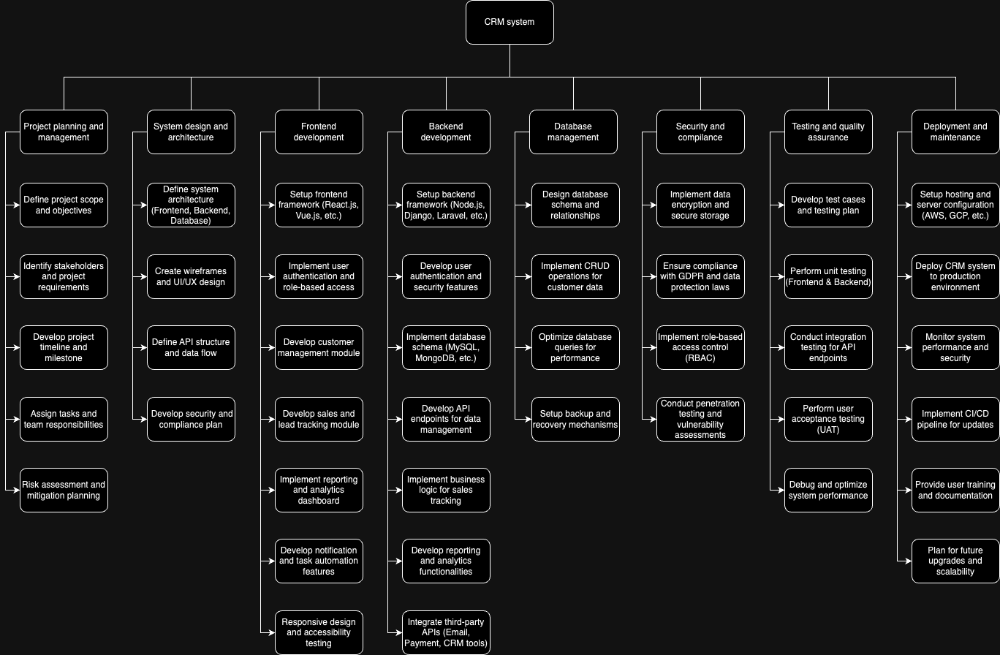

## Gantt chart

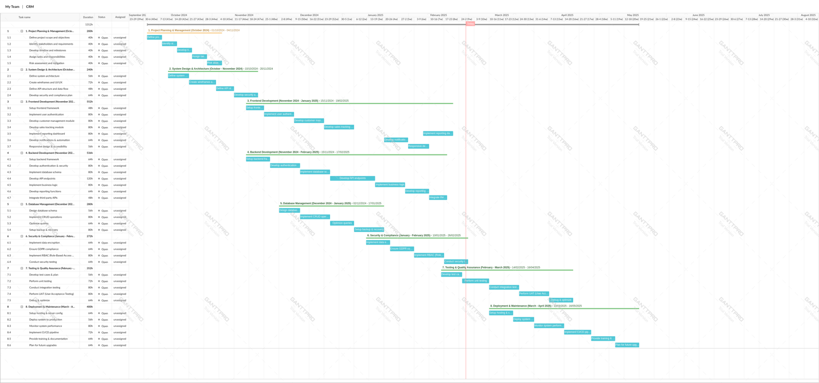

# Bibliography

Dodig-Crnkovic, G., 2003. *Computing Curricula: Social, Ethical, and Professional Issues.* [Online]   
Available at: https://www.academia.edu/35111232/Computing_Curricula_Social_Ethical_and_Professional_Issues  
[Accessed 27 February 2025].

GeeksforGeeks, 2024. *Software Development Life Cycle (SDLC).* [Online]   
Available at: https://www.geeksforgeeks.org/software-development-life-cycle-sdlc/  
[Accessed 27 February 2025].

Nguyen, J., 2024. *ViinDoo.* [Online]   
Available at: https://viindoo.com/blog/business-management-3/crm-system-912  
[Accessed 27 February 2025].